Task B)
1. Overview of the Detection Results (Faster R-CNN)

The object detection was performed on an image sequence provided using a Faster R-CNN–based model, and the detections were visualized as a video output.
Faster R-CNN works by first generating Region Proposals (RPN) and then classifying them into object categories with bounding boxes.

Overall, the detector was able to:
- Perform well in good lighting and low clutter scenes
- Correctly detect prominent objects present in most frames which are well separated from the background.
- Maintain reasonable bounding box accuracy when objects are clearly visible

However, several failure cases were observed, which are discussed below.
Failure observation
1)Missed Detections:
Objects that are detected correctly in some frames disappear in adjacent frames, even though they are still present in the scene. In some frames, objects that are clearly visible to the human eye are not detected at all.
- Object appears too small in the frame
- Partial occlusion by other objects
- Object moves to the edge of the frame
- Low contrast between object and background.

2)Incorrect or false positive Detections:
Some background regions are incorrectly classified as objects, in which most likely shadows are detected as objects. Static objects are detected very inconsistently across frames as well.
- Similar texture or shape between background and trained object classes
- Insufficient confidence threshold
- Model trained on a different dataset than the test images

3) Inaccurate or loose Bounding Boxes:
Bounding boxes in certain frames do not cover the entire object and are larger than the object. It is also observed that there is slight shift between consecutive frames as they extend beyond object boundaries.
- Object motion between frames
- Partial occlusion
- Aspect ratio mismatch between anchor boxes and object shape.

4)Detection Flickering Across Frames
The same object is detected in one frame and is missed in the subsequent frame; The object is again detected in the next frame which results in the flickering of the bounding box in the output video.
- Slight changes in pose, lighting, or scale
- Confidence score fluctuates around the detection threshold

5) Sensitivity to Lighting and Motion Blur
Detection quality is observed to be decreased under low-light conditions as well as frames with motion blur. Also, in frames where we can observe sudden illumination changes or low contrast regions the detection quality appears to be reduced.

The Faster R-CNN–based object detection system performs well in controlled conditions but shows limitations when applied to image sequences with:
* Occlusions
* Motion blur
* Small objects
* Background clutter

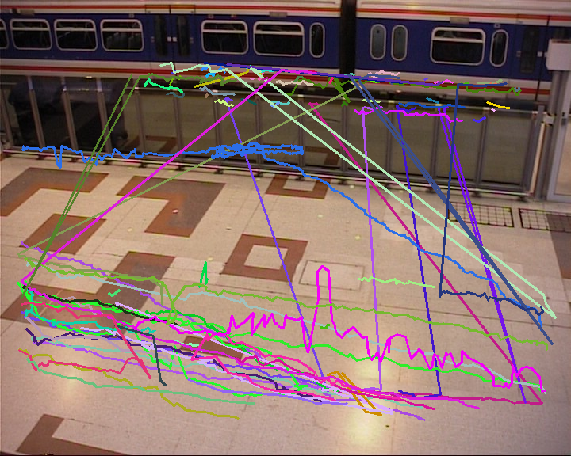
Figure 1: Tracks for τ = 2

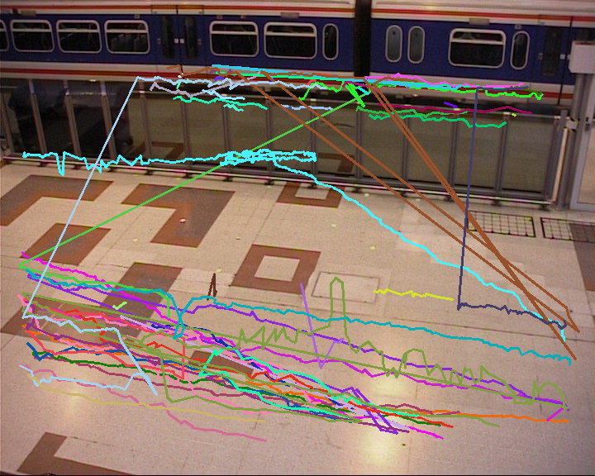
Figure 2: Tracks for τ = 5

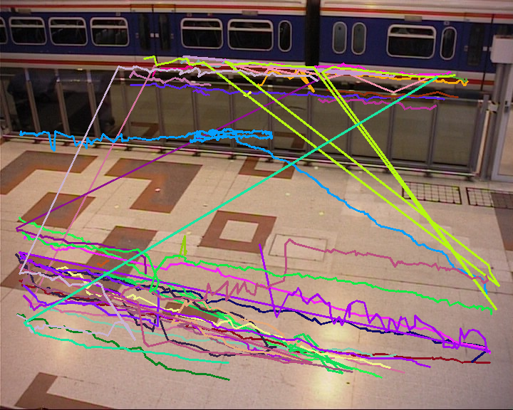
Figure 3: Tracks for τ = 10

Total tracks (τ = 2): 107
Total tracks (τ = 5): 64
Total tracks (τ = 10): 42

1. Comparison of Results for Different τ Values

The parameter τ controls how long a track can survive without being assigned a detection. Its value significantly affects the number of tracks, track length, and accuracy of track associations.
1) τ = 2 (Strict/Low tolerance)
* Observation:
- Many tracks are short and fragmented.
- Tracks terminate quickly if a detection is missed even for 1–2 frames.
- Flickering in detection causes frequent track endings.
* Trajectories appear short, disconnected lines on the first frame image as well as higher number of lines generated out of the three cases studied.

2) τ = 5 (Moderate tolerance)
* Observation:
- Tracks persist longer through temporary detection failures.
- Fewer fragmented tracks compared to τ = 2.
- Smooth trajectories are visible in most cases.
* Lines are longer and smoother, showing continuous motion of each pedestrian.

3) τ = 10 (High tolerance)
* Observation:
- Tracks survive even when detections are missing for many frames.
- Very long trajectories are formed, even when the object disappears temporarily.
* Trajectories are very long, sometimes overlapping or incorrectly connected.

Based on the above observation we can discuss the effect of τ on Performance:

- Small τ (τ = 2): Tracks terminate quickly → more fragmented tracks → high total track count.
- Moderate τ (τ = 5): Tracks survive short gaps → smoother trajectories → moderate track count.
- Large τ (τ = 10): Tracks survive long gaps → low total track count but risk of incorrect associations.

Conclusion: τ controls the trade-off between track fragmentation and incorrect association. A moderate value (τ = 5) is usually optimal for this assignment scenario.

Failure Cases of the Implemented Approach

Despite being simple and effective, the tracking by detection approach has some limitations:
1. Crossing Objects:
When two pedestrians cross or come very close, the tracker may incorrectly assign a detection from one to the track of another because it only uses spatial distance.
2. Long Occlusions:
If a pedestrian is occluded for longer than τ frames, the track is terminated and may be reassigned to a different pedestrian later.
3. No Appearance Modelling:
Only spatial distance is used, so objects with similar positions can be confused.

4. Rapid Movement:
Fast-moving objects may “jump” far between frames. If the jump exceeds the closest-distance assignment, the tracker may fail to link detections correctly.
5. Detection Failures:
Since tracking depends on the detector, if Faster R-CNN misses an object, the tracker cannot maintain continuity.

Task C:
Distance-based tracking: τ=2, total tracks=107
Distance-based tracking: τ=5, total tracks=64
Distance-based tracking: τ=10, total tracks=42
Appearance-based tracking: τ=5, total tracks=64
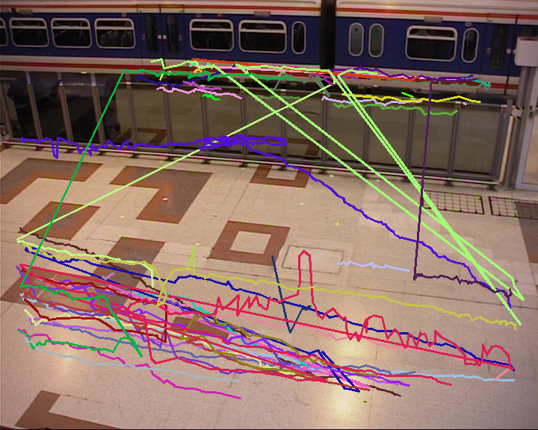
Figure 4: Tracking by appearance (τ=5)

Approach:
- Each detection is represented by a colour histogram extracted from the bounding box.
- Tracks are assigned by minimizing a combined score of spatial and appearance distances.
- If no match is found, a new track is initialized.
- Tracks are terminated after τ frames without assignment.
Reason for Choice:
- Colour histograms are fast to compute, robust to small motion, and differentiate pedestrians with distinct clothing.
- Combining appearance and spatial distance reduces identity switches when pedestrians cross or are close.
- Simpler than deep features, sufficient for this assignment.
Advantages:
- Tracks pedestrians more consistently through occlusions or missed detections.
- Reduces misassignment compared to using spatial distance alone.
Limitations:
- Fails when pedestrians wear similar clothing or lighting changes drastically.
- Fast motion can still break tracks.
- Identity switches possible if two pedestrians have similar appearance.
“Although Task 3 focuses on appearance-based tracking, we also include distance-based tracking results as a baseline reference. This allows us to compare performance and highlight improvements due to appearance features. Three τ values (2, 5, 10) are shown for distance-based tracking to illustrate how track termination tolerance affects track length and fragmentation. For appearance-based tracking, a single τ value (5) is used because appearance information already improves track continuity, making multiple τ tests less critical.
Why only one τ value for appearance-based tracking?
- Appearance-based tracking already uses additional cues (colour histograms) to maintain track continuity.
- This naturally reduces fragmentation, so testing multiple τ values is less critical.
- Typically, a moderate τ (like 5) is enough to demonstrate the improvement over distance-only tracking.
- Focus is on showing the effect of appearance information, not tuning τ.
Why three τ values for distance-based tracking?
- τ = 2, 5, 10 were tested in Task 2 to study the effect of track termination tolerance:
  - Small τ (2): Tracks end quickly → fragmented tracks
  - Moderate τ (5): Tracks survive short detection gaps → smoother trajectories
  - Large τ (10): Tracks survive longer → risk of incorrect associations
- These multiple τ values help show how track length and continuity change, which is a key part of Task 2 analysis

Task D:
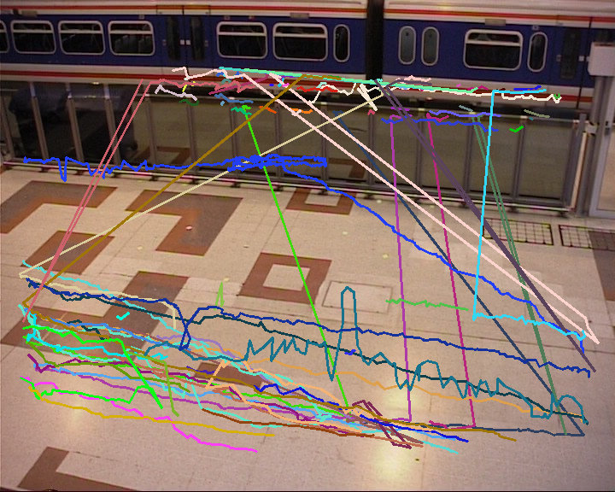
Figure 5: Tracking by appearance (τ = 2)
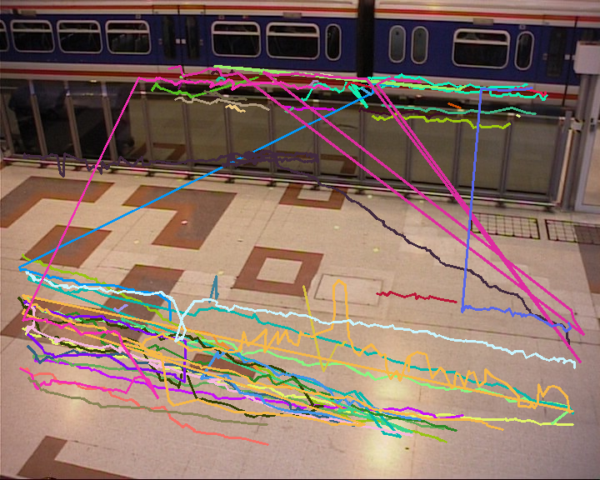
Figure 6: Tracking by appearance (τ = 5)
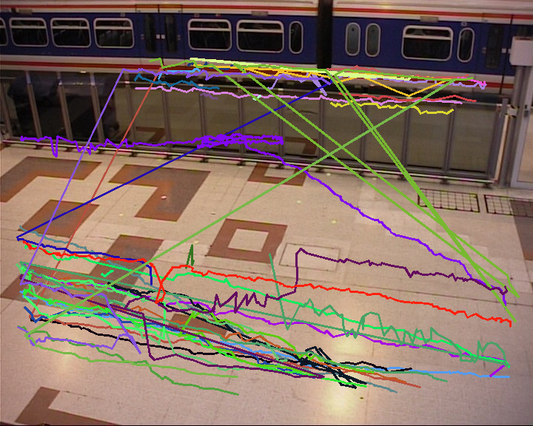
Figure 7: Tracking by appearance (τ = 10)

Aspect | Task 2 – Distance Only | Task 3 – Appearance-based
Assignment criterion | Smallest Euclidean distance between centre | Combination of colour appearance + spatial distance
Track consistency | Tracks often break during occlusion or flickering | Tracks persist better through brief occlusions or missed detections
Identity switches | High when pedestrians cross | Reduced, since appearance helps distinguish similar positions
Sensitivity to τ | Small τ → fragmented tracks; large τ → possible wrong association | Same trend, but appearance reduces misassignment for large τ
Limitations | Cannot handle similar positions | Cannot handle identical clothing or large lighting changes

Theoretical Analysis: Appearance-Based Tracking
Procedure for Testing Appearance-Based Tracking
The second variant of tracking by detection (Task 3) assigns detections to tracks based on appearance features, rather than just spatial distance. The procedure follows the same steps as in Task 2, with τ controlling how long a track can survive without a detection:
Feature Extraction:
For each detected bounding box, an appearance descriptor is computed. In this implementation, a color histogram in HSV space is used.
Histograms are normalized to account for different box sizes.
Detection-to-Track Assignment:
For each detection in the current frame, compute distance to each active track:
Appearance distance: similarity between current histogram and last histogram of track
Optional spatial distance: Euclidean distance between centres
Assign the detection to the track with lowest combined score (weighted sum of spatial and appearance distances).
Track Initialization and Termination:
If a detection cannot be assigned to any existing track, a new track is initialized.
If a track does not get assigned any detection for τ consecutive frames, it is terminated.
Testing Multiple τ Values:
The tracker is evaluated for τ = 2, 5, 10.
Tracks are visualized on the first frame by connecting the centres of bounding boxes across frames.
The total number of tracks is recorded for each τ value.
Observed Differences and Reasons
Track Length and Continuity:
Appearance-based tracking produces longer, smoother tracks because similarity in appearance allows tracks to survive brief occlusions or missed detections.
Distance-based tracking often breaks tracks during occlusion or detection flickering.
Reduced Identity Switches:
When two pedestrians are close or cross each other:
Distance-based tracker may assign the wrong detection.
Appearance-based tracker uses colour histograms to maintain correct associations, reducing identity swaps.
Effect of τ:
For both methods:
τ = 2: Tracks terminate quickly → fragmented tracks
τ = 5: Balanced → moderate track continuity
τ = 10: Tracks persist longer → risk of incorrect associations increases
Appearance-based tracking allows longer τ without significant identity switches, improving robustness

